**Actividad PRO 5.1 Junit**

**Código de la clase “miCalculadora”**

**Código de la clase Junit**

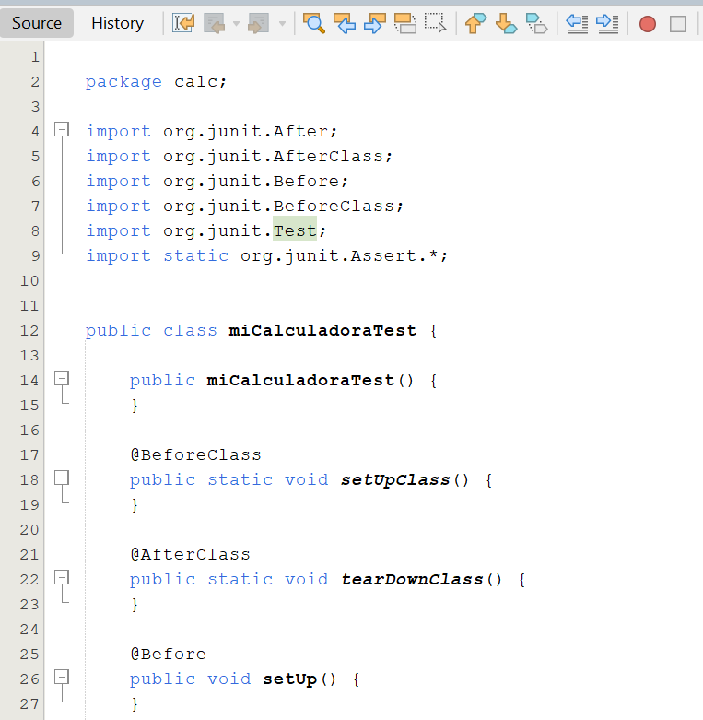

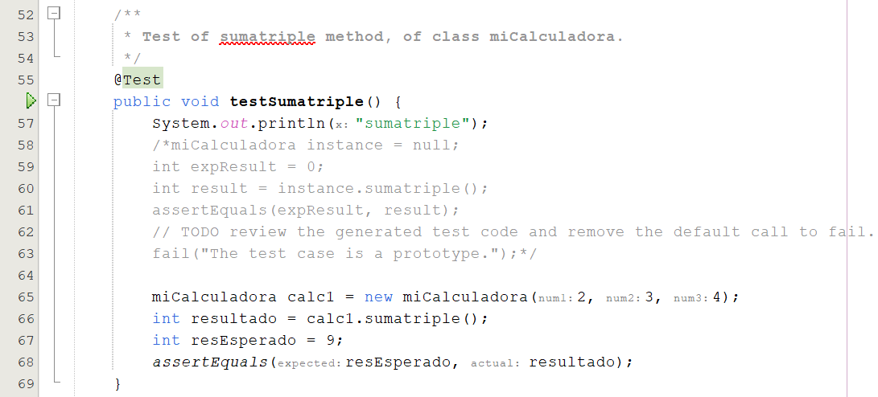

**Resultado del Test**

